**Nama : Siska Andria Putri**

**Npm : 4508210005**

**Tugas : Lapran Praktek Pemrograman 4**

**Sesi-2 : - Anatomi Aplikasi Java**

**- Classpath**

**Deklarasi Class**

**Cara Pertama:**

public class Person{}

**Cara Kedua:**

public class person{}

class persaon2{}

class person3{}

class person4{}

**Cara Ketiga:**

public class person{

private class person2{}

private static class person3{}

class person4{}

**Cara Keempat:**

public class person {

private Runnable thread = new Runnable(){

public void run(){

System.out.println("Hellowrld from Thread");

**Deklarasi Interface**

1. public class person {

private Long id;

private String nama;

public String getNama(){

return nama;

}

public void setNama(String nm){

nama = nm;

}

public Long getId(){

return id;

}

public void setId(Long i){

id = i;

}

1. public interface personDao{

void save(person p);

void delete(person p);

person getById(Long id);

**}**

1. public class personDaoImpl implements personDao{

public void save(person p){

System.out.println("menyimpan person");

}

public void delete(person p){

System.out.println("manghapus person");

}

public person getById(Long id){

person p = new person();

p.setId(id);

p.setNama("abc");

return p;

}

} }

**Class vs Object**

public class person{

person siska = new person();

}

**Method**

public class person{

public void IniMethod(){

}

public String getName(){

return "dani";

}

public void methodParam(String nama){

}

private int tambah(int a, int b){

return a+b;

}

}

**Constructor**

public class person{

public person(){

}

public person(String nama){

System.out.println(nama);

}

public person(String nama, int l){

System.out.println(nama + l);

}

}

1. Cara pemanggilannya:

public class panggil {

person p = new person();

public static void main(String args[]){

person p2 = new person("jimmy");

person p3 = new person("dadang",1);

}

}

**Property**

public class person{

private Long id;

private String nama;

public String getNama(){

return nama;

}

public void setNama(String nm){

nama = nm;

}

public Long getId(){

return id;

}

public void setId(Long i){

id = i;

}

}

**Sesi-3 : - Variabel**

**- Tipe Data**

**Praktikum soal 1**

public class Person

{

public static void main(String[] args)

{

int value = 10;

char x;

x = 'A';

System.out.println(value);

System.out.println("The value of x = " + x);

}

}

**Proses hasil running:**

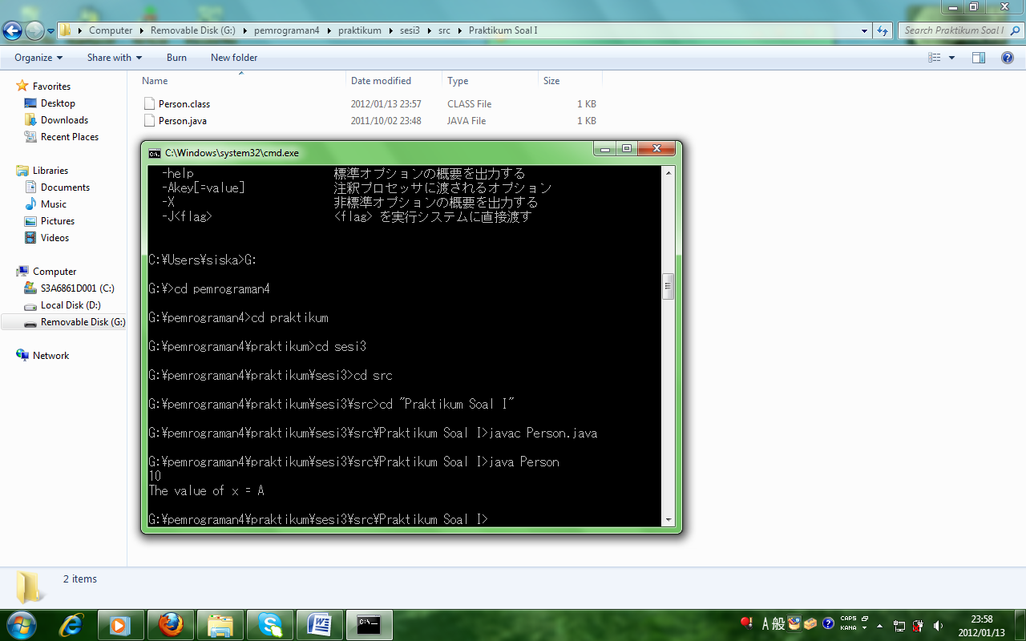

**Praktikum soal II**

public class Person

{

private String nama;

public static void main(String[] args)

{

Person test;

test = new Person();

test.setNama("andi");

byte b = 100;

short s = 100;

Person belajarVariabel = test;

belajarVariabel.setNama("belajar variabel");

System.out.println(b + s);

System.out.println("nama : " + test.getNama() + " " + b);

}

public void setNama(String aNama)

{

this.nama = aNama;

}

public String getNama()

{

return this.nama;

}

}

**Proses hasil running:**

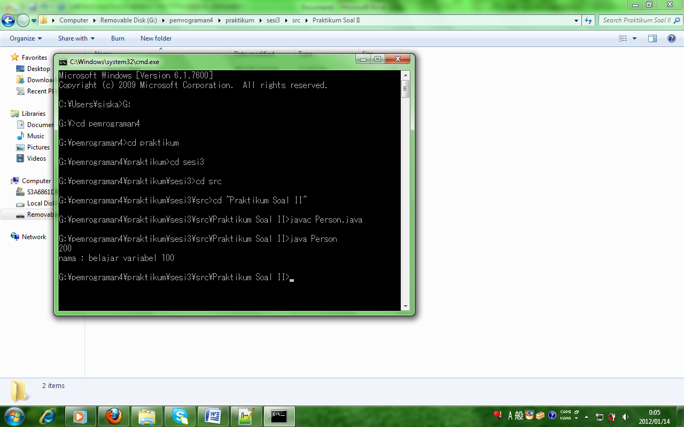

**Praktikum soal III**

public class Person

{

public static void main(String[] args)

{

int ourfirstnumber = 10;

double ourfirstdouble = 10;

System.out.println(ourfirstnumber);

System.out.println(ourfirstdouble);

}

}

**Proses hasil running:**

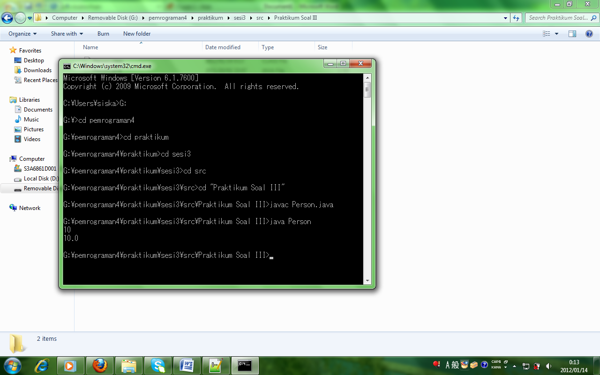

**Praktikum soal IV**

public class Person

{

public static void main(String[] args)

{

byte number1 = 12;

short number2 = 100;

int number3 = 1000;

long number4 = 20001;

float number5 = 120023.45f;

double number6 = 123456;

boolean value = true;

char character = 'a';

System.out.println(number1);

System.out.println(number2);

System.out.println(number3);

System.out.println(number4);

System.out.println(number5);

System.out.println(number6);

System.out.println(value);

System.out.println(character);

}

}

**Proses hasil running:**

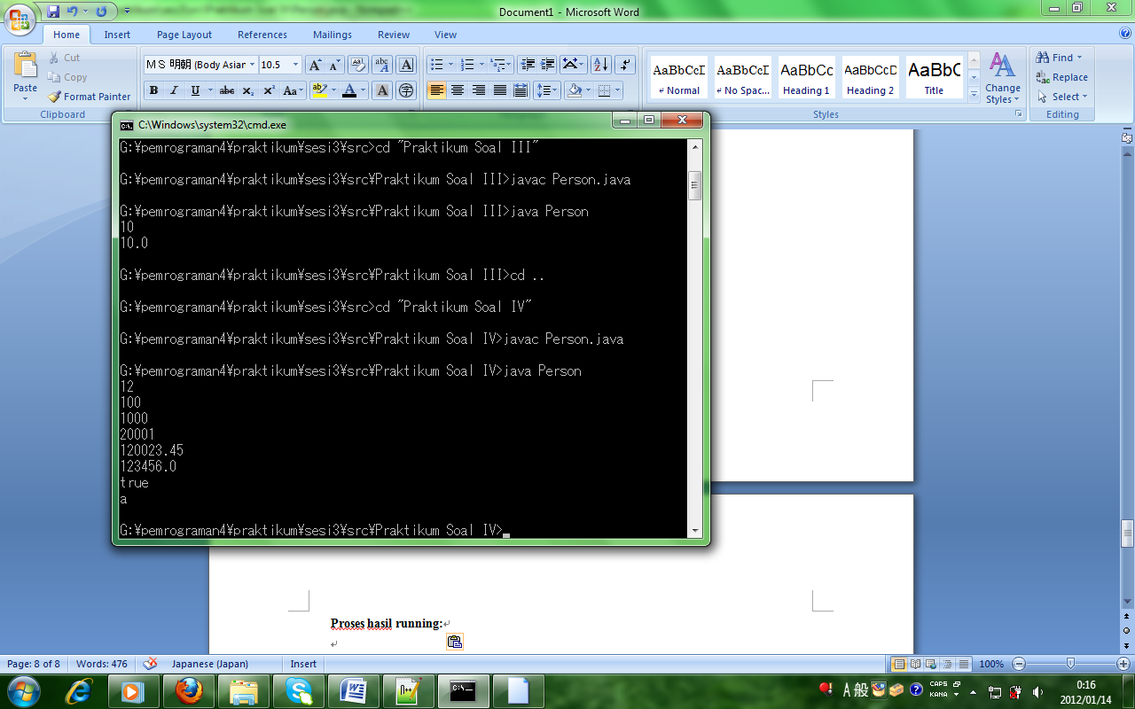

**Praktikum soa V**

public class Person

{

public static void main(String[] args)

{

int a;

a = 1000;

int b = 1000;

System.out.println("a = " + a);

System.out.println("b = " + b);

System.out.println("a + b = " + (a + b));

}

}

**Proses hasil running:**

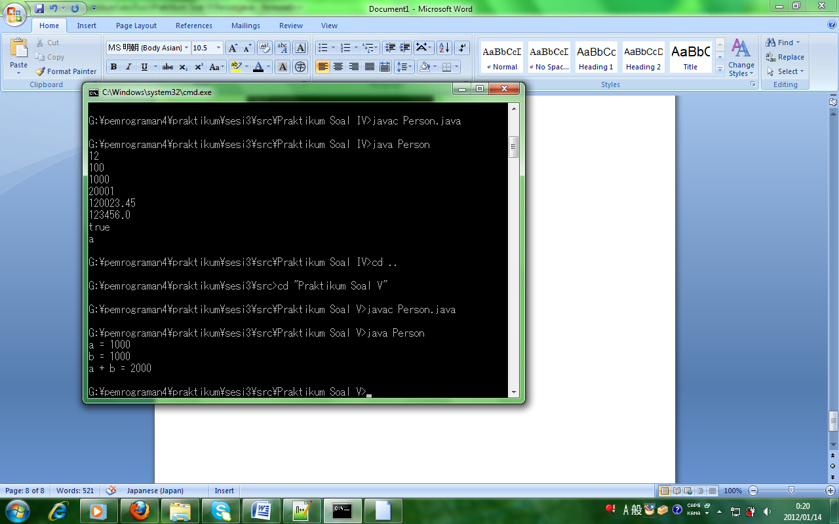

**Sesi-4 : - Operator**

**- Control flow(if-else,for/while)**

**Soal 1**

public class Latihan{

public static void main(String[] args){

int age = 21;

System.out.println(age > 50 ? "You are old" : "You are young");

}

}

**Proses hasil running:**

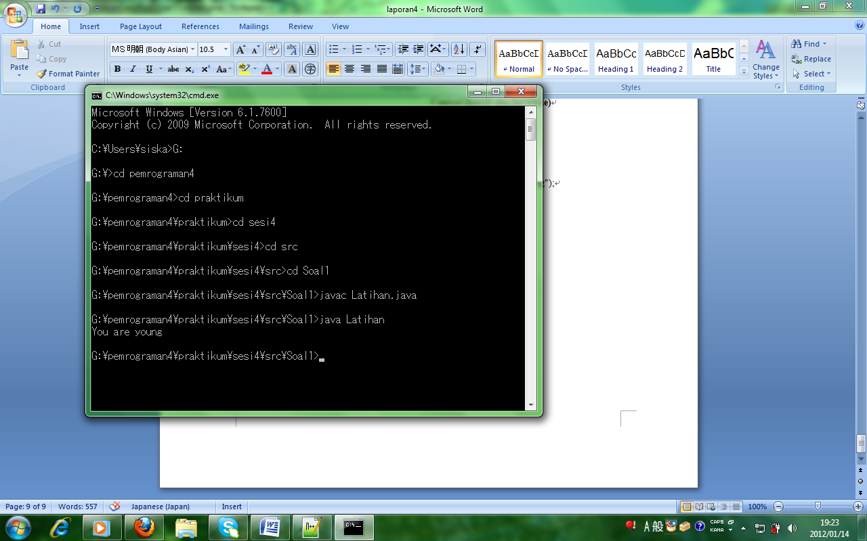

**Soal 2**

public class Latihan{

public static void main(String args[]){

for(int x = 0; x < 7; x++){

System.out.println("Hello, Worlds we are using loops");

}

}

}

**Proses hasil running:**

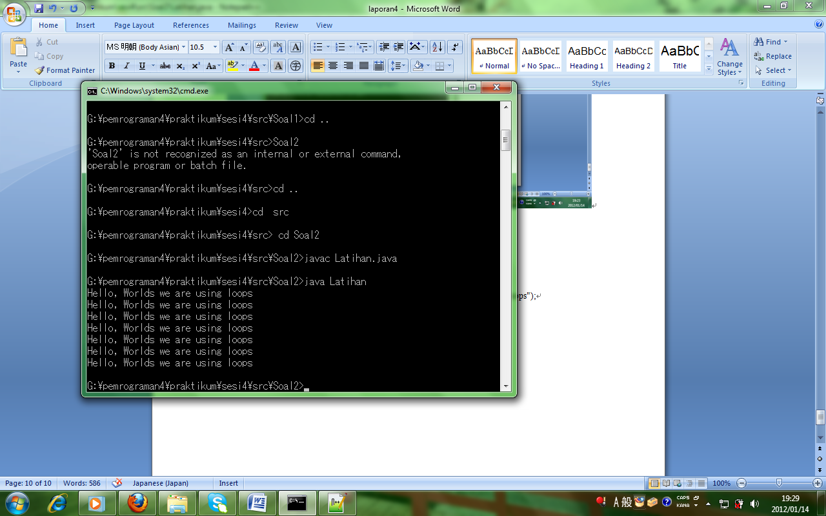

**Soal 3**

public class Latihan{

public static void main(String args[]){

while(true){

System.out.println("Hello, Worlds we are using loops");

}

}

}

**Proses hasil running:**

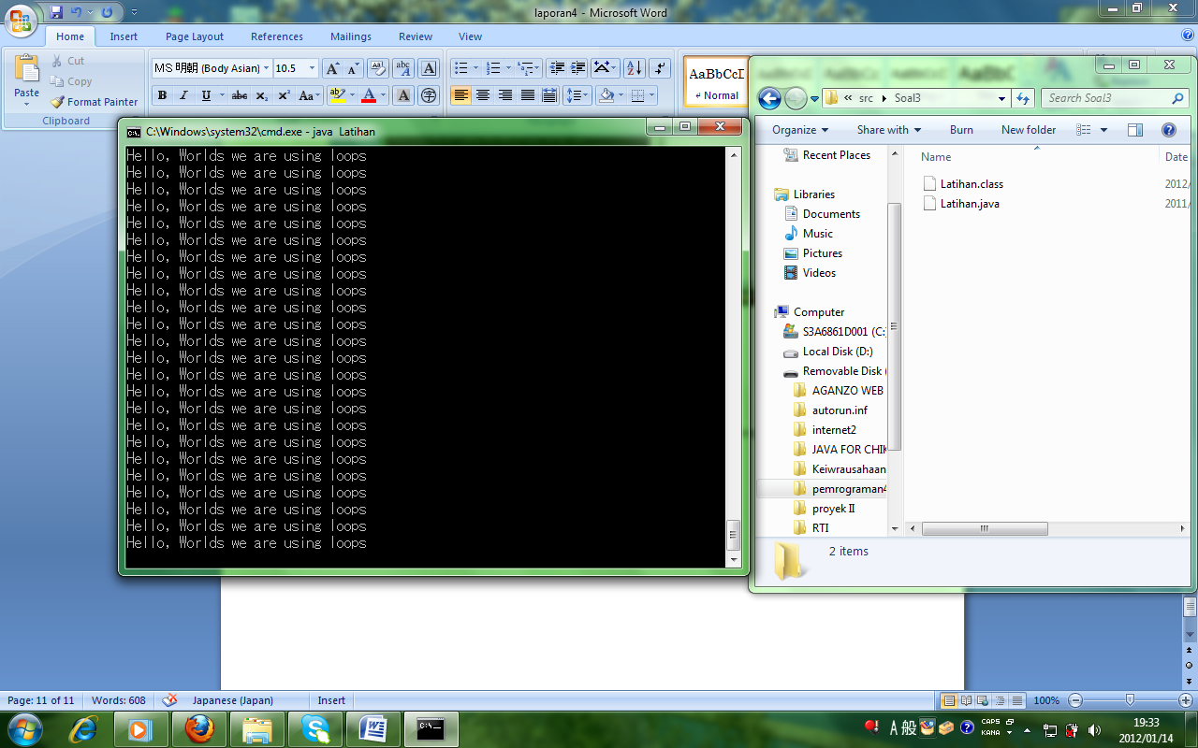

**Soal 4**

public class Latihan{

public static void main(String[] args){

System.out.println("Instr 1");

if(1>2){

System.out.println("Instr 2");

} else{

System.out.println("Instr 3");

}

System.out.println("Instr 4");

}

}

**Proses hasil running:**

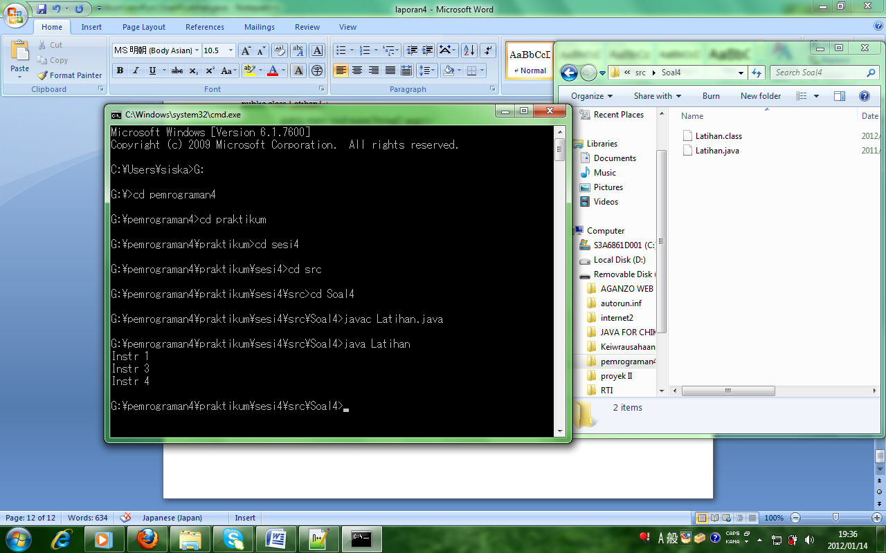

**Soal 5**

public class Latihan{

public static void main(String args[]){

int a = 5;

System.out.println(a++);

System.out.println(a);

}

}

**Proses hasil running:**

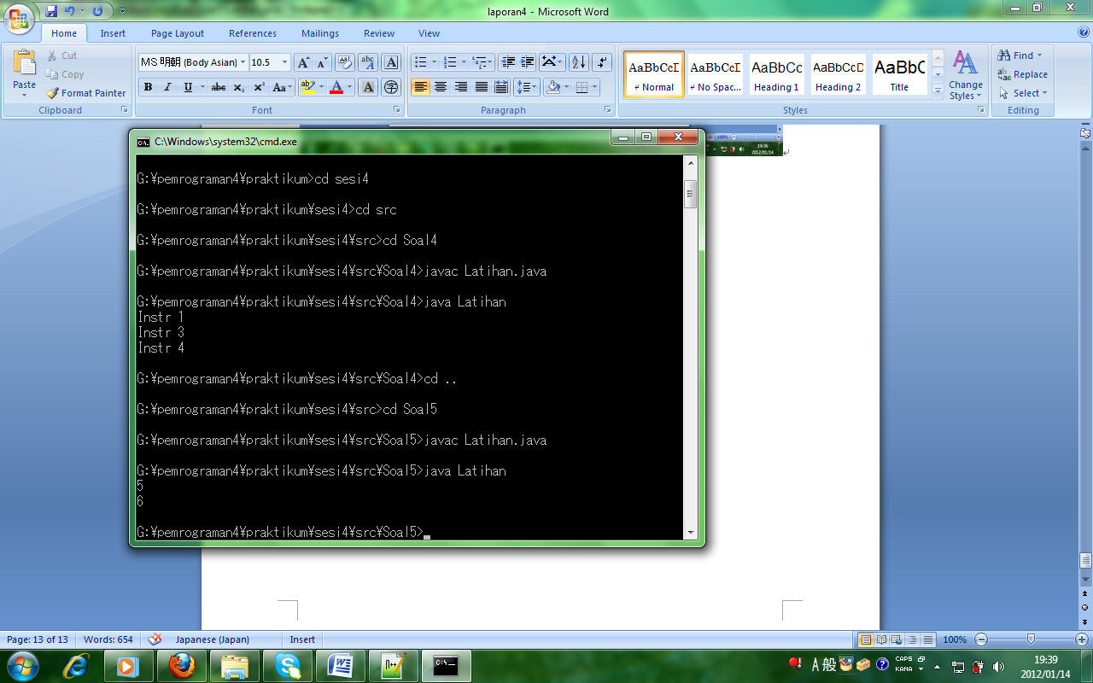

**Soal 6**

public class Latihan{

public static void main(String args[]){

boolean coba1;

boolean coba2;

coba1 = (10 == 1);

System.out.println(coba1);

}

}

**Proses hasil running:**

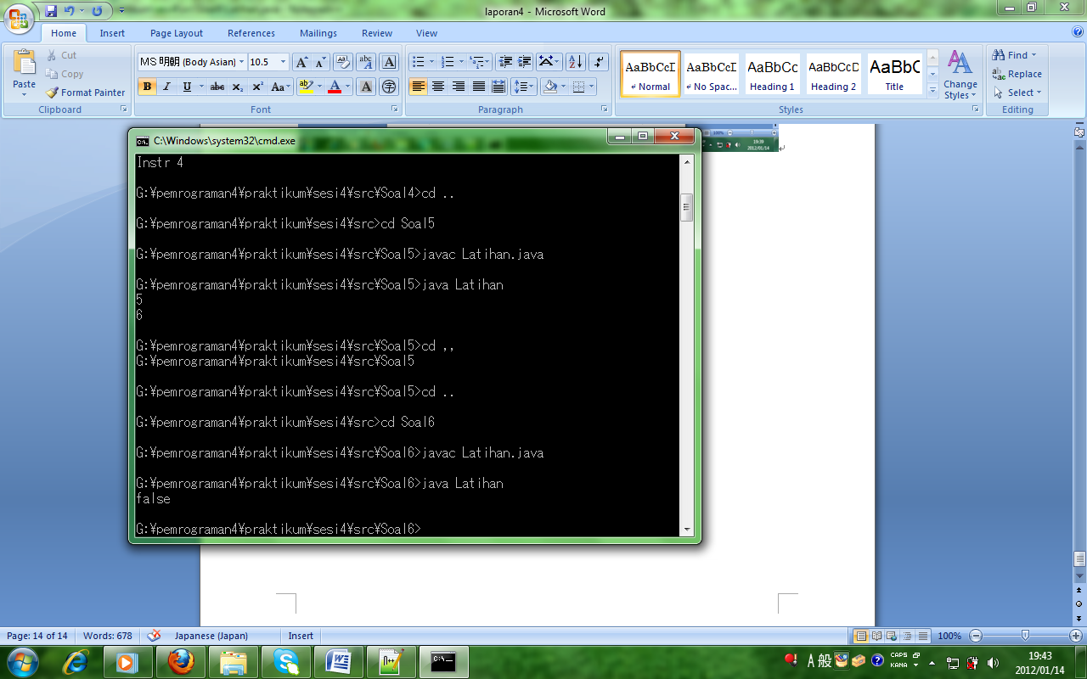

**Soal 7**

public class Latihan{

public static void main(String args[]){

int firstNumber, secondNumber, results;

firstNumber = 20;

secondNumber = 10;

results = firstNumber + secondNumber;

System.out.println(results);

}

}

**Proses hasil running:**

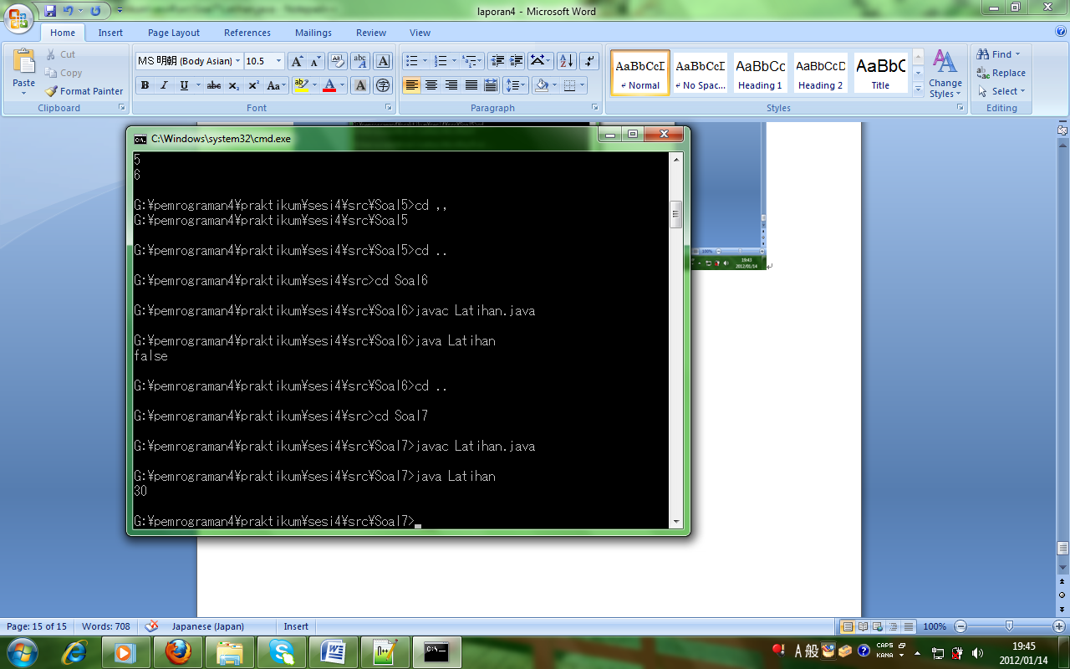

**Soal 8**

public class Latihan{

public static void main(String args[]){

int count = 1;

while(count < 5){

System.out.println("Count is equal to " + count);

count++;

}

}

}

**Proses hasil running**

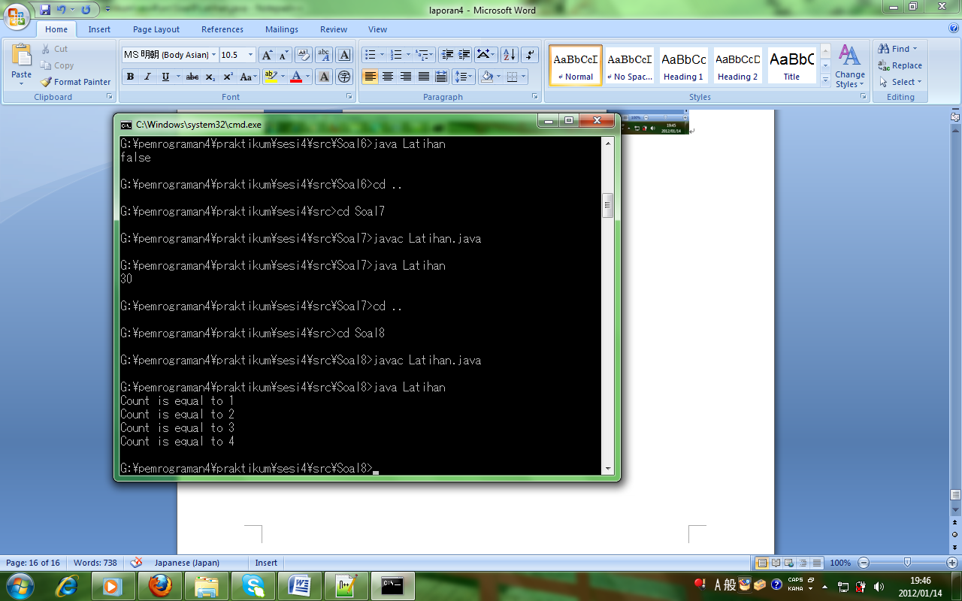

**Soal 9**

public class Latihan{

public static void main(String[] args){

int a=4, b=6;

int num=a|b;

if(num==4)

System.out.println("value is 4");

else if(num==5)

System.out.println("value is 5");

else if(num==6)

System.out.println("value is 6");

else if(num==7)

System.out.println("value is 7");

}

}

**Proses hasil running:**

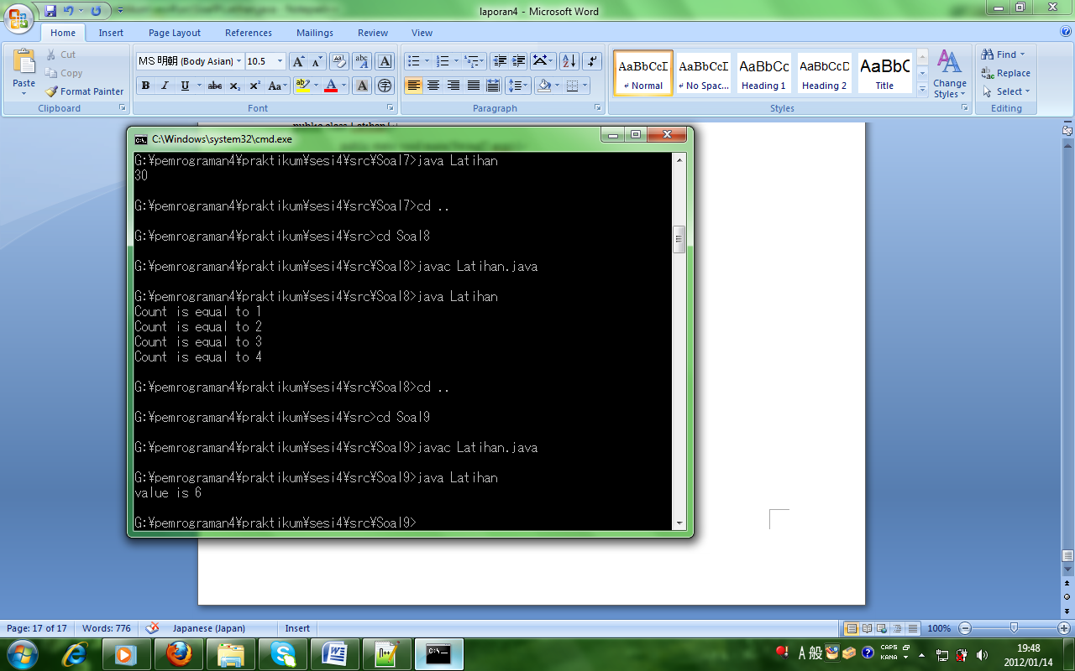

**Soal 10**

public class Latihan{

public static void main(String[] args){

int num=11;

if(num > 5)

System.out.println("Number is Greater Than 5");

else

System.out.println("Number is Less Than 5");

}

}

**Proses hasil running:**

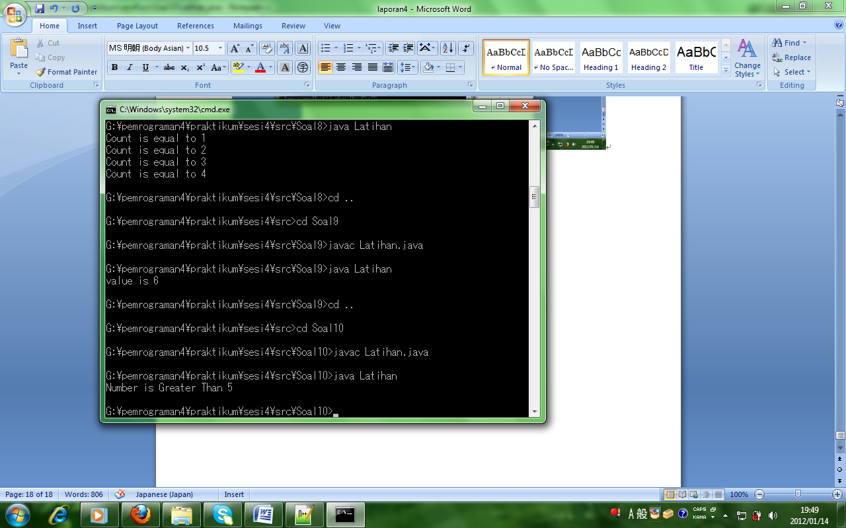

**Sesi-5 : - Class & Object**

**Class & Object**

**Perpustakaan.txt:**

001, Adi Prayoga, Panduan Lengkap memakai Adobe

002, Putri Indriyani, Tutorial Windows Server 2003

003, Femmy Agustina, Google Adsense

004, Andi Andriana, Pemrograman Basis Data Lanjut MySQL

005, Putra Pratama, Panduan Dasar Autocad 2005

**File Perpustakaan.java dengan sintaks:**

public class Perpustakaan {

private String id;

private String peminjam;

private String judul;

private static Integer Jumlah;

public String getJudul() {

return judul;

}

public void setJudul(String judul) {

this.judul = judul;

}

public String getPeminjam() {

return peminjam;

}

public void setPeminjam(String peminjam) {

this.peminjam = peminjam;

}

public String getId() {

return id;

}

public void setId(String Id) {

this.id = id;

}

public static Integer jumlah;

public static Integer getJumlah (){

return jumlah;

}

public static void setJumlah(Integer jumlah){

Perpustakaan.jumlah = jumlah;

}

}

**File Perpustakaan.main dengan sintaks:**

import java.io.BufferedInputStream;

import java.io.DataInputStream;

import java.io.File;

import java.io.FileInputStream;

import java.io.IOException;

import java.util.ArrayList;

import java.util.List;

public class PerpustakaanMain {

public static void main (String[] args) {

File file = new File ("F:/pemrograman4/praktikum/sesi5/src/perpustakaan/Perpustakaan.txt");

FileInputStream fis = null;

BufferedInputStream bis = null;

DataInputStream dis = null;

List<Perpustakaan> listPerpustakaan = new ArrayList<Perpustakaan>();

try {

fis = new FileInputStream(file);

bis = new BufferedInputStream(fis);

dis = new DataInputStream(bis);

int count=0;

while(dis.available() !=0) {

count ++;

//memecah text perbaris menjadi beberapa kolom sesuai dengan pemisah koma

String line = dis.readLine();

String[] data = line.split(",");

Perpustakaan p = new Perpustakaan();

p.setJumlah(count);

p.setId(data[0]);

p.setPeminjam(data[1]);

p.setJudul(data[2]);

listPerpustakaan.add(p);

}

} catch (IOException ex) {

System.out.println("File " + file.getName() + " tidak ketemu !");

System.out.println("Exception : " + ex.getMessage() );

}

for (Perpustakaan perpus : listPerpustakaan) {

System.out.println("========================");

System.out.println("ID : " + perpus.getId());

System.out.println("Penyewa : " + perpus.getPeminjam());

System.out.println("Judul : " + perpus.getJudul());

System.out.println("Jumlah : " + perpus.getJumlah());

}

}

}

**Proses hasil running:**

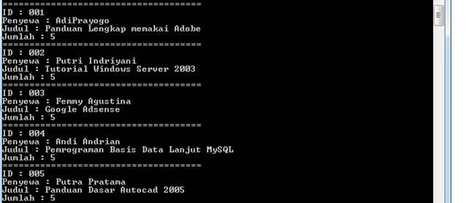

**Sesi-6 : - Method**

**- Exception**

**Praktikum soal 1**

**File whitespaceException.java dengan sintaks:**

public class WhiteSpaceException extends Exception{

public WhiteSpaceException() {

super("Terjadi kesalahan : 'tidak boleh ada spasi / whitespace'");

}

public WhiteSpaceException(String text) {

super("Terjadi kesalahan : 'tidak boleh ada spasi / whitespace', text : " + text);

}

}

**File whiteSpaceMain.java dengan sintaks:**

import java.util.Arrays;

import java.util.logging.Level;

import java.util.logging.Logger;

public class WhiteSpaceMain {

public static void main(String[] args) {

try {

input();

}catch (WhiteSpaceException ex) {

Logger.getLogger(WhiteSpaceMain.class.

getName()).log(Level.SEVERE, null, ex);

}

}

public static void input() throws

WhiteSpaceException {

String username = "TIdak Boleh Memakai Spasi";

char[] charArray = username.toCharArray();

for (char c : charArray)

{

if(c == ' ')

{

throw new WhiteSpaceException

(username);

}

}

System.out.println("Kalimat ini " + username);

}

}

**Proses hasil running:**

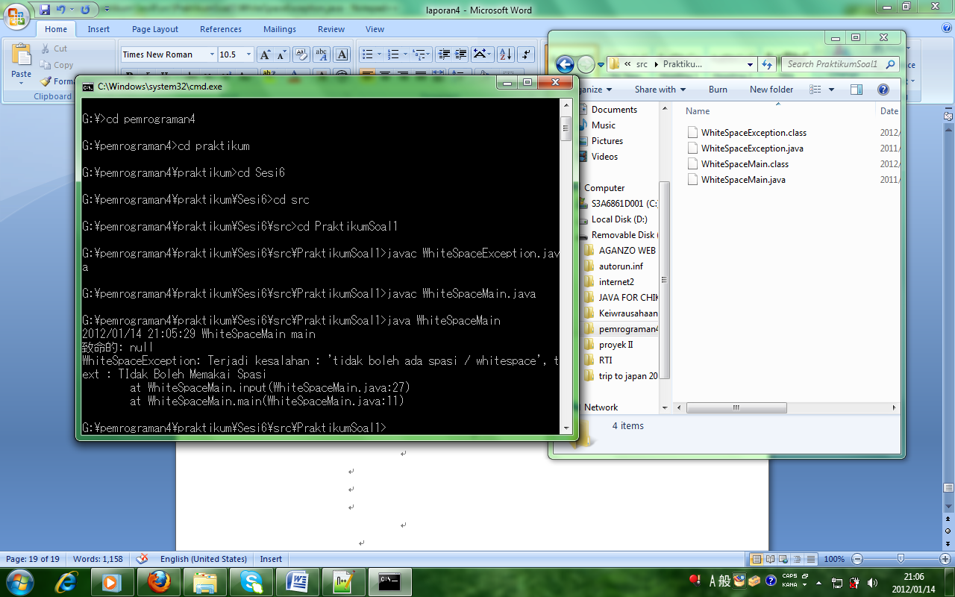

**Praktikum soal 2**

**File MethodReturnValues dengan sintaks:**

public class MethodReturnValues

{

public static void main(String[] args)

{

myMethod();

int myInt = 0;

System.out.println(myInt);

myInt = myMethod();

System.out.println(myInt);

}

static int myMethod()

{

System.out.println("This computer is lagging!");

return 4;

}

}

**Proses hasil running:**

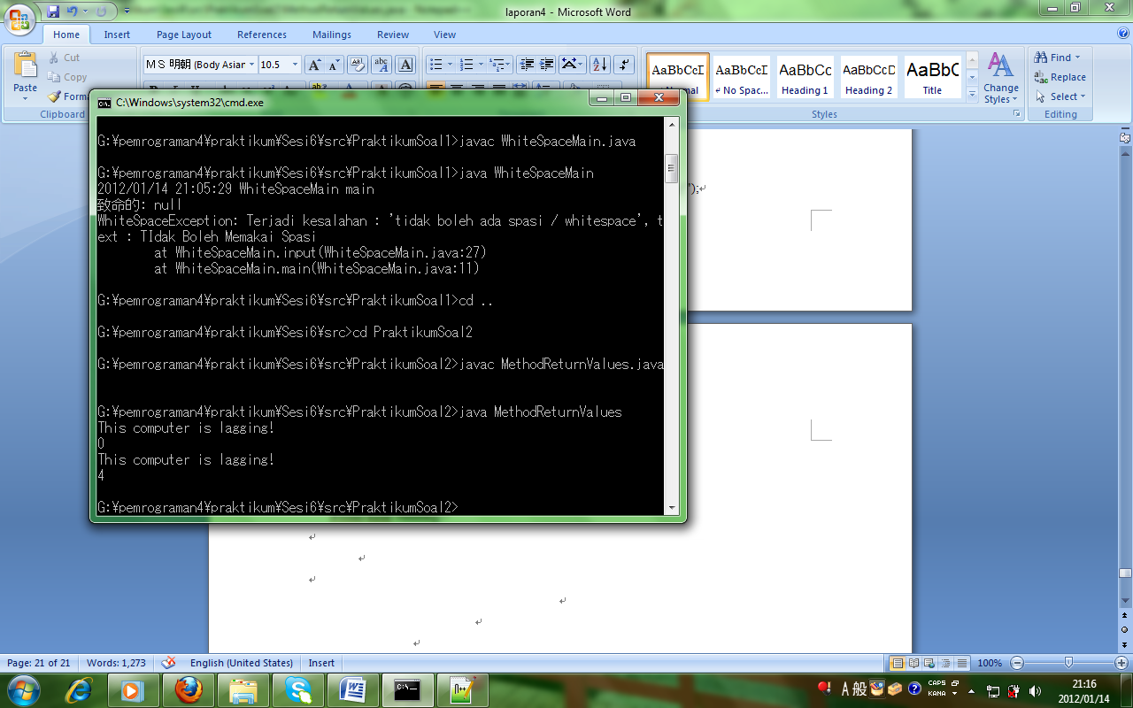

**Praktikum soal 3**

**File Person.java dengan sintaks:**

public class Person

{

public static void simpleMessage(String name)

{

System.out.println("Hello " + name);

}

}

**File Method.java dengan sintaks:**

import java.util.Scanner;

public class Method

{

public static void main(String[] args)

{

Scanner input = new Scanner(System.in);

Person personObject = new Person();

System.out.println("Enter your name : ");

String name = input.nextLine();

personObject.simpleMessage(name);

}

}

**Proses hasil running:**

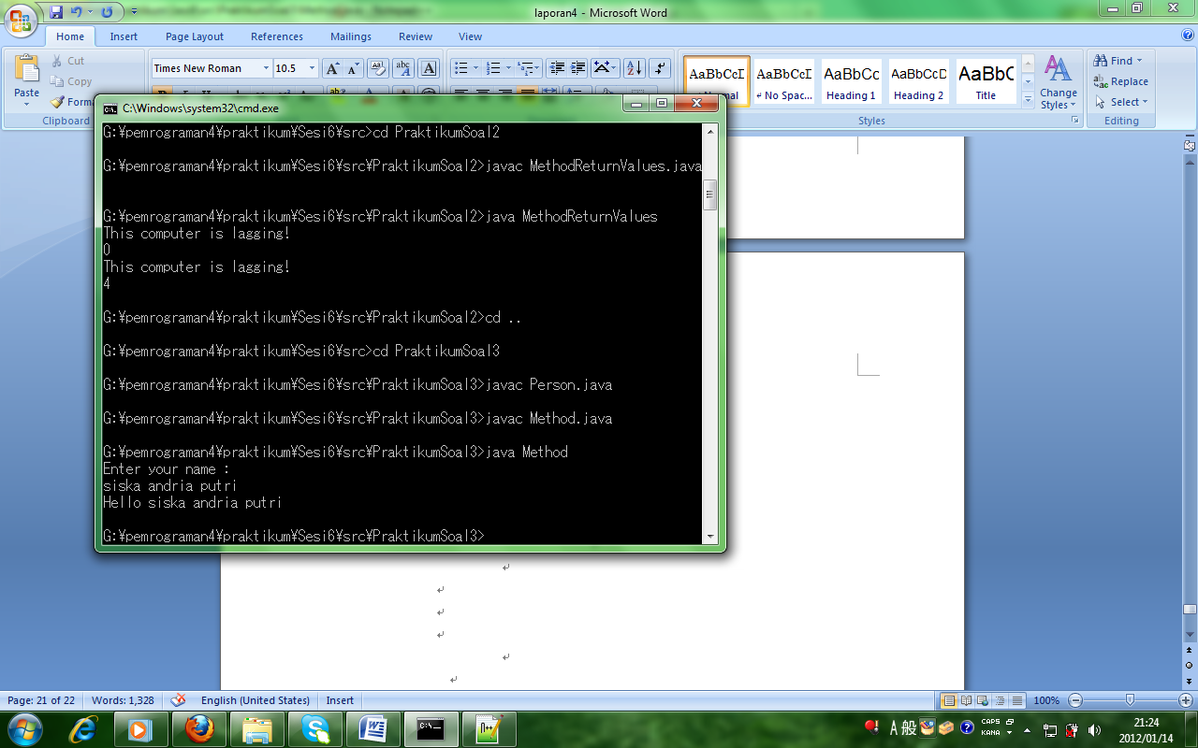

**Praktikum soal 4**

**File ExceptionTest.java dengan sintaks:**

import java.util.*;

public class ExceptionTest {

public static void main(String[] args) {

Scanner input = new Scanner(System.in);

int x = 1;

do {

try {

System.out.println("Enter first num : ");

int n1 = input.nextInt();

System.out.println("Enter second num : ");

int n2 = input.nextInt();

int sum = n1/n2;

System.out.println(sum);

x = 2;

} catch(Exception e) {

System.out.println("You can do that");

}

}

while (x == 1);

}

}

**Proses hasil running:**

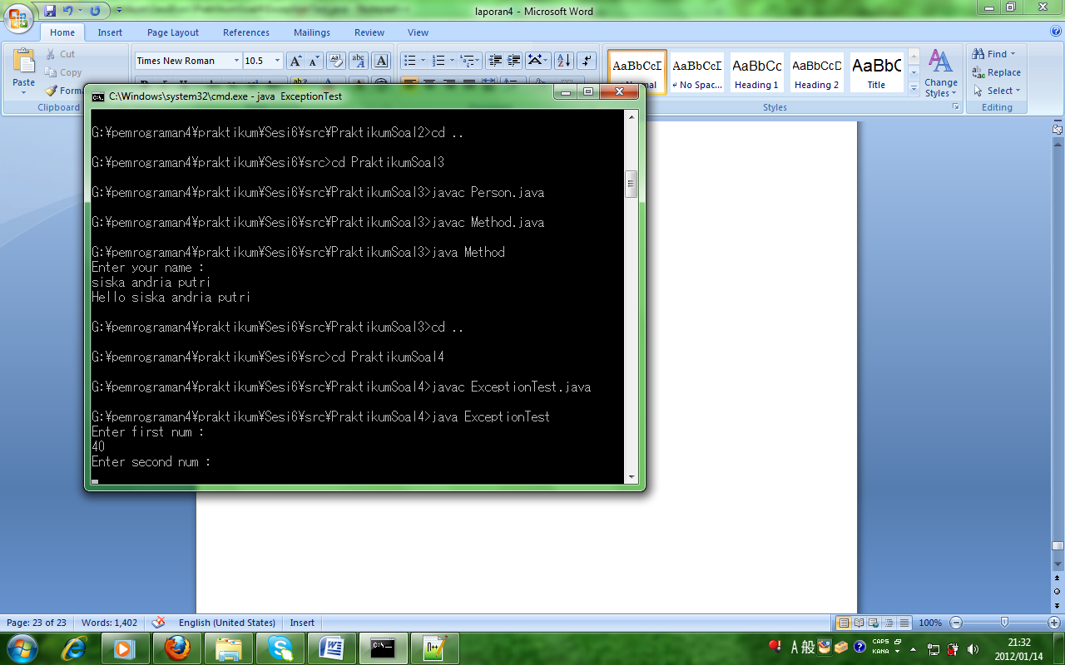

**Proses hasil running:**

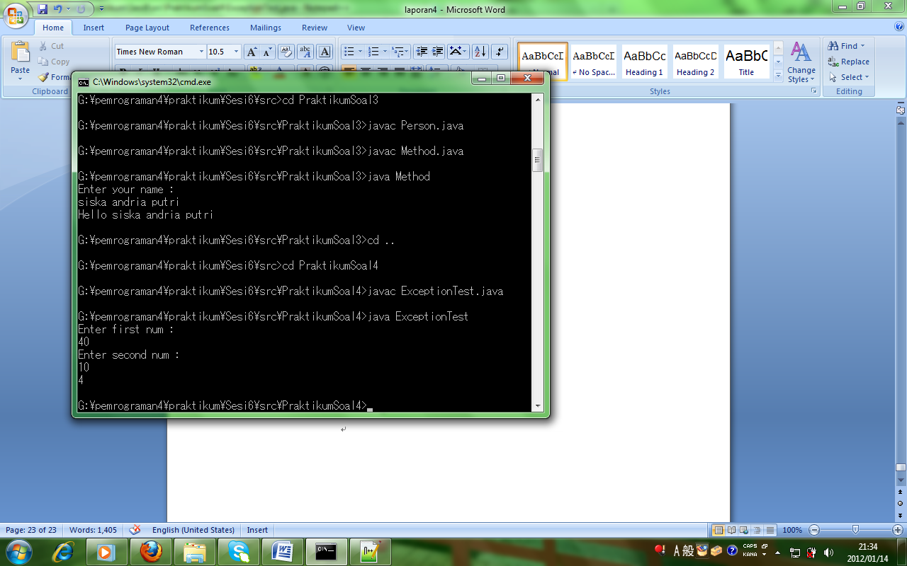

**Proses hasil running:**

Error liat temen

**Sesi-7 : - Konsep OOP**

**- Implement Inheritance**

**Praktikum Soal 1**

**File CalculatorServiceImpl.java dengan sintaks:**

package service.impl;

import service.CalculatorService;

public class CalculatorServiceImpl implements CalculatorService{

@Override

public Integer tambah(int bil1, int bil2) {

return bil1 + bil2;

}

@Override

public Integer kurang(int bil1, int bil2) {

return bil1 - bil2;

}

@Override

public Integer kali(int bil1, int bil2) {

return bil1 * bil2;

}

@Override

public Integer bagi(int bil1, int bil2) {

return bil1 / bil2;

}

}

**File CalculatorService.java dengan sintaks:**

package service;

public interface CalculatorService {

public Integer tambah (int bil1, int bil2);

public Integer kurang (int bil1, int bil2);

public Integer kali (int bil1, int bil2);

public Integer bagi (int bil1, int bil2);

}

**File MainClass.java dengan sintak:**

package main;

import service.CalculatorService;

import service.impl.CalculatorServiceImpl;

public class MainClass {

public static void main(String[] args) {

CalculatorService service = new

CalculatorServiceImpl();

Integer a = service.tambah(200, 4);

Integer b = service.kurang(200, 4);

Integer c = service.kali(200, 4);

Integer d = service.bagi(200, 4);

System.out.println("Output");

System.out.println("Nilai a : " + a);

System.out.println("Nilai b : " + b);

System.out.println("Nilai c : " + c);

System.out.println("Nilai d : " + d);

}

}

**Proses hasil running:**

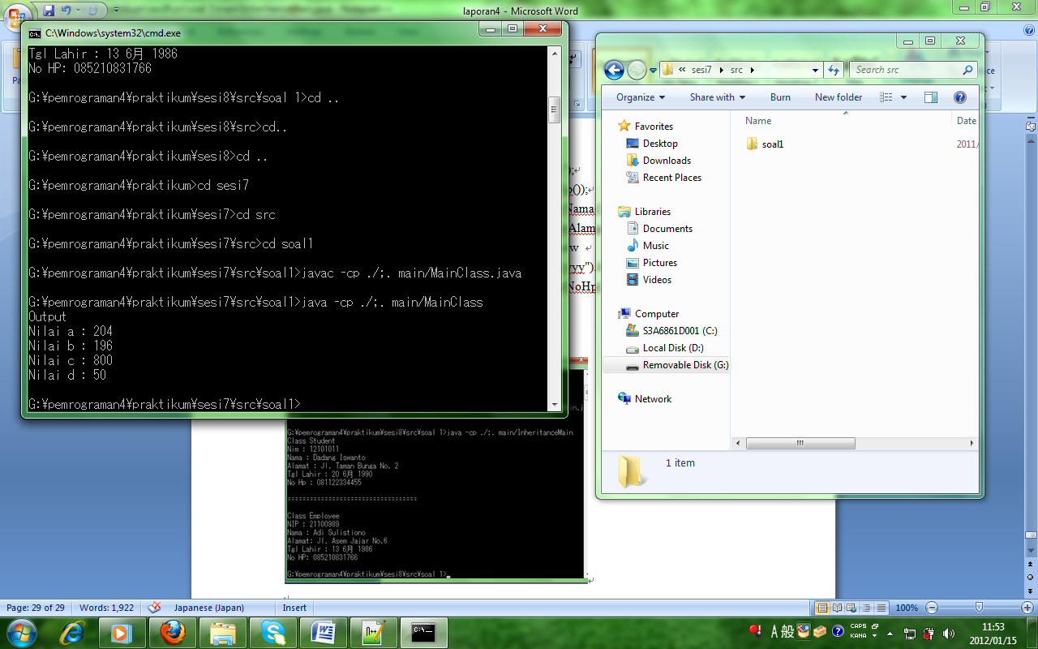

**Sesi-8 : - Inheritance**

**Praktikum Soal 1**

**File Person.java dengan sintaks:**

package model;

import java.util.Date;

public class Person {

private String nama;

private String alamat;

private String noHp;

private Date tglLahir;

public String getAlamat(){

return alamat;

}

public void setAlamat(String alamat){

this.alamat = alamat;

}

public String getNama(){

return nama;

}

public void setNama(String nama){

this.nama = nama;

}

public String getNoHp(){

return noHp;

}

public void setNoHp(String noHp){

this . noHp = noHp;

}

public Date getTglLahir(){

return tglLahir;

}

public void setTglLahir(Date tglLahir){

this.tglLahir = tglLahir;

}

}

**File Student.java dengan sintaks:**

package model;

public class Student extends Person{

private String nim;

public String getNim(){

return nim;

}

public void setNim(String nim){

this.nim = nim;

}

}

**File Employee.java dengan sintaks:**

package model;

public class Employee extends Person{

private String nip;

public String getNip(){

return nip;

}

public void setNip(String nip){

this.nip = nip;

}

}

**File InheritanceMain.java dengan sintaks:**

package main;

import java.text.ParseException;

import java.text.SimpleDateFormat;

import model.Employee;

import model.Student;

public class InheritanceMain {

public static void main(String[] args) throws ParseException{

Student s = new Student();

s.setNim("12101011");

s.setNama("Dadang Iswanto");

s.setAlamat ("Jl. Taman Bunga No. 2");

s.setTglLahir(newSimpleDateFormat("dd-MM-yyyy").parse ("20-06-1990"));

s.setNoHp("081122334455");

Employee e = new Employee();

e.setNip("21100989");

e.setNama("Adi Sulistiono");

e.setAlamat("Jl. Asem Jajar No.6");

e.setTglLahir(newSimpleDateFormat("dd-MM-yyyy").parse ("13-06-1986"));

e.setNoHp("085210831766");

showData (s);

System.out.println

("\n===================================\n");

showData(e);

}

static void showData (Student s){

System.out.println("Class Student");

System.out.println("Nim : " + s.getNim());

System.out.println("Nama : " + s.getNama());

System.out.println("Alamat : " + s.getAlamat());

System.out.println("Tgl Lahir : " + new

SimpleDateFormat("dd MMMMM yyyy").format(s.getTglLahir()));

System.out.println("No Hp : " + s.getNoHp());

}

static void showData (Employee e){

System.out.println("Class Employee");

System.out.println("NIP : " + e.getNip());

System.out.println("Nama : " + e.getNama());

System.out.println("Alamat: " + e.getAlamat());

System.out.println("Tgl Lahir : " + new

SimpleDateFormat("dd MMMMM yyyy").format(e.getTglLahir()));

System.out.println("No HP: " + e.getNoHp());

}

}

**Proses hasil running:**

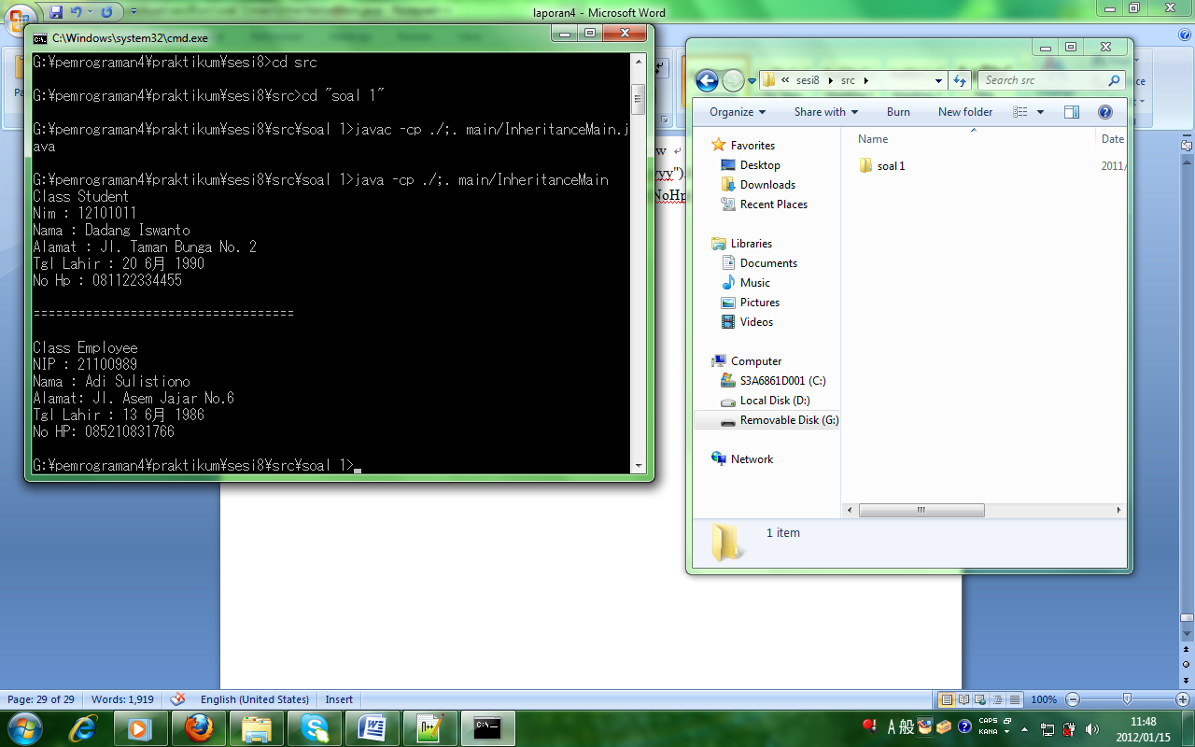

**Sesi-9 : - “Calculator”**

**File MainClass.java dengan sintaks:**

package main;

import service.CalculatorService;

import service.impl.CalculatorServiceImpl;

import java.util.*;

import java.io.*;

public class MainClass {

public static void main(String[] args) throws IOException{

String var1, var2, var3;

String operatornya;

CalculatorService service = new CalculatorServiceImpl();

//bilangan1

System.out.println("Masukkan bilangan 1:");

InputStreamReader converter = new InputStreamReader(System.in);

BufferedReader in = new BufferedReader(converter);

var1 = in.readLine();

int nilai1 = Integer.parseInt(var1);

//bilangan2

System.out.println("Masukkan bilangan 2:");

InputStreamReader converter2 = new InputStreamReader(System.in);

BufferedReader in2 = new BufferedReader(converter2);

var2 = in2.readLine();

int nilai2 = Integer.parseInt(var2);

//operator

System.out.println("Masukkan operatornya:");

System.out.println("KETERANGAN:");

System.out.println("1 = tambah:");

System.out.println("2 = kurang:");

System.out.println("3 = kali:");

System.out.println("4 = bagi:");

InputStreamReader converter3 = new InputStreamReader(System.in);

BufferedReader in3 = new BufferedReader(converter3);

//System.out.println(nilai1);

var3 = in3.readLine();

int x= Integer.parseInt(var3);

switch(x)

{

case 1 :

Integer a = service.tambah(nilai1, nilai2);

System.out.println("Output");

System.out.println("Hasil tambah : " + a);

break;

case 2 :

Integer b = service.kurang(nilai1, nilai2);

System.out.println("Output");

System.out.println("hasil kurang : " + b);

break;

case 3 :

Integer c = service.kali(nilai1, nilai2);

System.out.println("Output");

System.out.println("Hasil kali : " + c);

break;

case 4 :

Integer d = service.bagi(nilai1, nilai2);

System.out.println("Output");

System.out.println("Hasil bagi : " + d);

break;

default :

System.out.println("KAGA ADA,GOBLOK...!!");

}

}

}

**File CalculatorServis.java dengan sintaks:**

package service;

public interface CalculatorService {

public Integer tambah (int bil1, int bil2);

public Integer kurang (int bil1, int bil2);

public Integer kali (int bil1, int bil2);

public Integer bagi (int bil1, int bil2);

}

**File CalculatorServiceImpl.java dengan sintaks:**

package service.impl;

import service.CalculatorService;

public class CalculatorServiceImpl implements CalculatorService{

@Override

public Integer tambah(int bil1, int bil2) {

return bil1 + bil2;

}

@Override

public Integer kurang(int bil1, int bil2) {

return bil1 - bil2;

}

@Override

public Integer kali(int bil1, int bil2) {

return bil1 * bil2;

}

@Override

public Integer bagi(int bil1, int bil2) {

return bil1 / bil2;

}

}

**Proses hasil running:**se

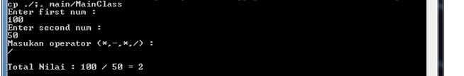

**Sesi-10 : - Encapsulation**

**- Polymorphism**

**Praktikum Soal 1**

**File Makanan.java dengan sintaks:**

public class Makanan {

void santap() {

System.out.println(" Saya Makan Ayam Bakar");

}

}

**File Minuman .java dengan sintaks:**

public class Minuman extends Makanan {

void santap() {

System.out.println("Saya Minum Es Teh Manis");

}

}

**File Cemilan.java dengan sintaks:**

public class Cemilan extends Makanan {

void santap() {

System.out.println("Saya Ngemil kacang");

}

}

**File Santapan.java dengan sintaks:**

public class Santapan {

public void cerna (Makanan x) {

x.santap();

}

}

**File Main.java dengan sintaks:**

class Main {

public static void main (String [] args) {

Santapan s= new Santapan();

Makanan ma= new Makanan();

Minuman mi= new Minuman();

Cemilan ce= new Cemilan();

s.cerna(ma);

s.cerna(mi);

s.cerna(ce);

}

}

**Proses hasil running:**

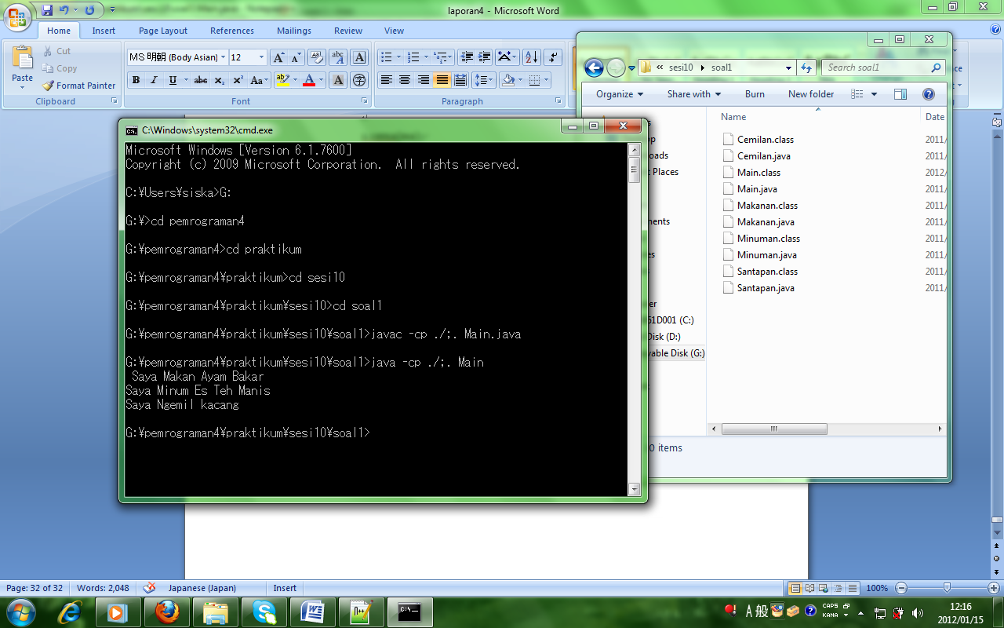

**Praktikum Soal 2**

**File PersegiPanjang.java dengan sintaks:**

public class PersegiPanjang{

private double panjang;

private double lebar;

private double tinggi;

public PersegiPanjang () {

panjang = 0 ;

lebar = 0;

}

private double luas(double p, double l) {

return p*l;

}

public void setPanjang (double panjang){

this.panjang = panjang;

}

public void setLebar(double lebar) {

this.lebar =lebar;

}

public double getPanjang() {

return panjang;

}

public double getLebar() {

return lebar;

}

public double getLuas() {

return luas(panjang, lebar);

}

}

**File MainPersegiPanjang.java dengan sintaks:**

public class MainPersegiPanjang {

public static void main(String [] srgs) {

PersegiPanjang pp =new PersegiPanjang();

pp.setPanjang(10);

pp.setLebar(20);

System.out.println("panjang : " + pp.getPanjang());

System.out.println("Lebar : "+ pp.getLebar());

System.out.println("Luas : "+ pp.getLuas());

}

}

**Proses hasil running:**

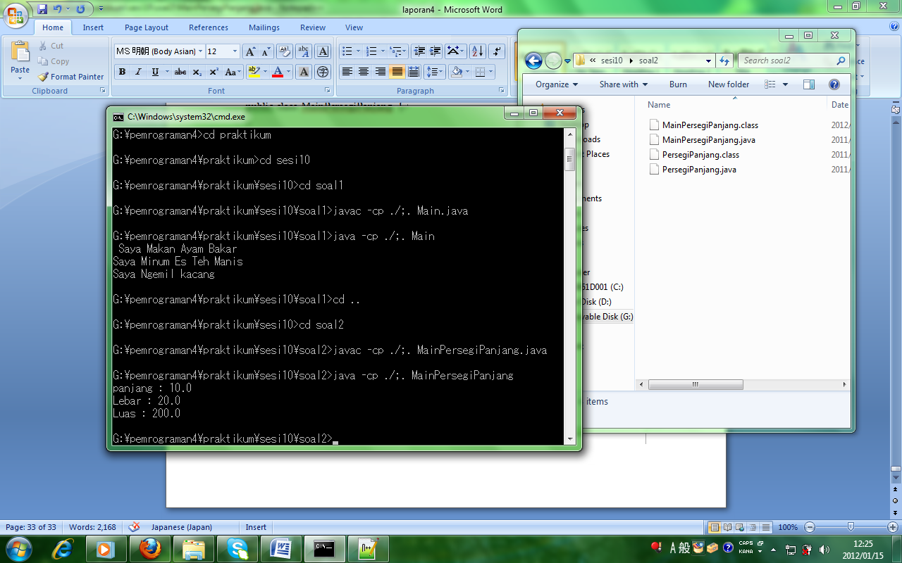

**Praktikum Soal 3**

**File EkspresiWajah.java dengan sintaks:**

public class EkspresiWajah {

public String respons() {

return("Perhatikan ekspresi wajah saya");

}

}

class Gembira extends EkspresiWajah {

public String respons() {

return("ha ha ha..");

}

}

class Sedih extends EkspresiWajah {

public String respons() {

return("hik hik ngeeee ngeeee ngeee..");

}

}

class Marah extends EkspresiWajah {

public String respons() {

return("Hai kurang ajar !");

}

}

**File MainEkspresiWajah.java dengan sintaks:**

class MainEkspresiWajah {

public static void main(String [] args) {

EkspresiWajah objEkspresi = new

EkspresiWajah();

Gembira objGembira = new Gembira();

Sedih objSedih = new Sedih();

Marah objMarah = new Marah();

EkspresiWajah[] arrEkspresi = new EkspresiWajah[4];

arrEkspresi[0] = objEkspresi;

arrEkspresi[1]= objGembira;

arrEkspresi[2]= objSedih;

arrEkspresi[3]=objMarah;

System.out.println("Ekspresi[0]): "+ arrEkspresi[0].respons());

System.out.println("Ekspresi[1]): "+ arrEkspresi[1].respons());

System.out.println("Ekspresi[2]): "+ arrEkspresi[2].respons());

System.out.println("Ekspresi[3]): "+ arrEkspresi[3].respons());

}

}

**Proses hasil running:**

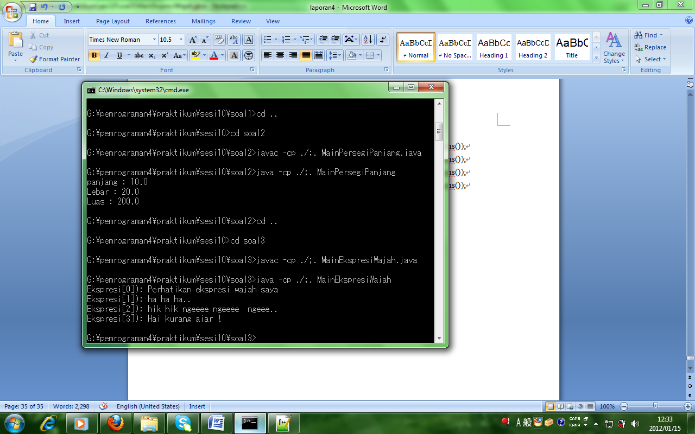

**Praktikum Soal 4**

**File Employee.java dengan sintaks:**

public class Employee{

private String name;

private double salary;

protected Employee(String n, double s){

name = n;

salary = s;

}

protected String getDetails(){

return "Name : "+name+ "\nSalary : "+salary;

}

public void cetak(){

System.out.println("Coba di Employee");

}

**File Manager.java dengan sintaks:**

public class Manager extends Employee{

private String department;

public Manager(String nama, double salary, String dep){

super(nama, salary);

department = dep;

}

public String getDepartment(){

return department;

}

public String getDetails(){

return super.getDetails()+"\nDepartment : "+getDepartment();

}

public void cetak(){

System.out.println("Coba di Manager");

}

}

}

**File View.java dengan sintaks:**

public class View{

public static void main(String[] args){

Employee e = new Employee("Ali",1200000);

Employee em = new Manager("Ali",1200000,"Informatika");

System.out.println("Data Employee :\n"+e.getDetails());

System.out.println("Data Manager :\n"+em.getDetails());

em.cetak();

}

}

**Proses hasil running:**

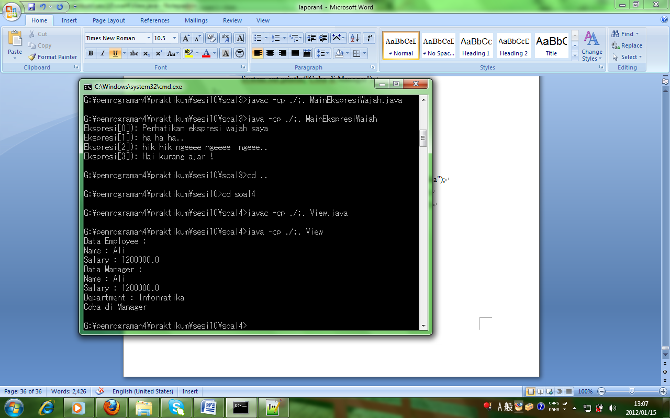

**Praktikum Soal 5**

**File Harga.java dengan sintaks:**

public interface Harga{

double biayaPerKg();

}

**File Paket.java dengan sintaks:**

public class Paket implements Harga{

private String nmPengirim;

private String tujuanPaket;

private int beratPaket;

private int biayaPerKg;

private double bayar;

public Paket(){

}

public String getNmPengirim(){

return nmPengirim;

}

public void setNmPengirim(String temp){

nmPengirim = temp;

}

public String getTujuanPaket(){

return tujuanPaket;

}

public void setTujuanPaket(String temp){

tujuanPaket = temp;

}

public int getBeratPaket(){

return beratPaket;

}

public void setBeratPaket(int temp){

beratPaket = temp;

}

public double biayaPerKg(){

if(tujuanPaket.equalsIgnoreCase("Bali")){

biayaPerKg = 10000;

return biayaPerKg;

} else if(tujuanPaket.equalsIgnoreCase("Surabaya")){

biayaPerKg = 15000;

return biayaPerKg;

} else if(tujuanPaket.equalsIgnoreCase("Jakarta")){

biayaPerKg = 20000;

return biayaPerKg;

} else{

biayaPerKg = 25000;

return biayaPerKg;

}

}

public double Bayar(){

bayar = beratPaket*biayaPerKg;

return bayar;

}

}

**File MainPengiriman.java dengan sintaks:**

import javax.swing.JOptionPane;

public class MainPengiriman extends Paket{

public MainPengiriman(){

}

public static void main(String[] args){

MainPengiriman elie = new MainPengiriman();

String nmPengirim = JOptionPane.showInputDialog("Biaya Pengiriman Paket" + "\n Inputkan Nama Pengirim ");

elie.setNmPengirim(nmPengirim);

String tujuanPaket = JOptionPane.showInputDialog("Biaya Pengiriman Paket" + "\n Inputkan Tujuan Paket : Bali | Surabaya | Jakarta | Bandung ");

elie.setTujuanPaket(tujuanPaket);

String br = JOptionPane.showInputDialog("Biaya Pengiriman Paket" + "\n Inputkan Berat Paket :");

int beratPaket = Integer.parseInt(br);

elie.setBeratPaket(beratPaket);

elie.biayaPerKg();

elie.Bayar();

JOptionPane.showMessageDialog(null,"Biaya Pengiriman Paket Adalah" + "\n Nama Pengirim :" + elie.getNmPengirim() + "\n Tujuan paket :" + elie.getTujuanPaket() + "\n Berat paket :" + elie.getBeratPaket() + " Kg" + "\n Biaya Per Kg :" + elie.biayaPerKg() + "\n Total Bayar :" + elie.Bayar() + "\n Terima Kasih...");

}

}

**Proses hasil running:**

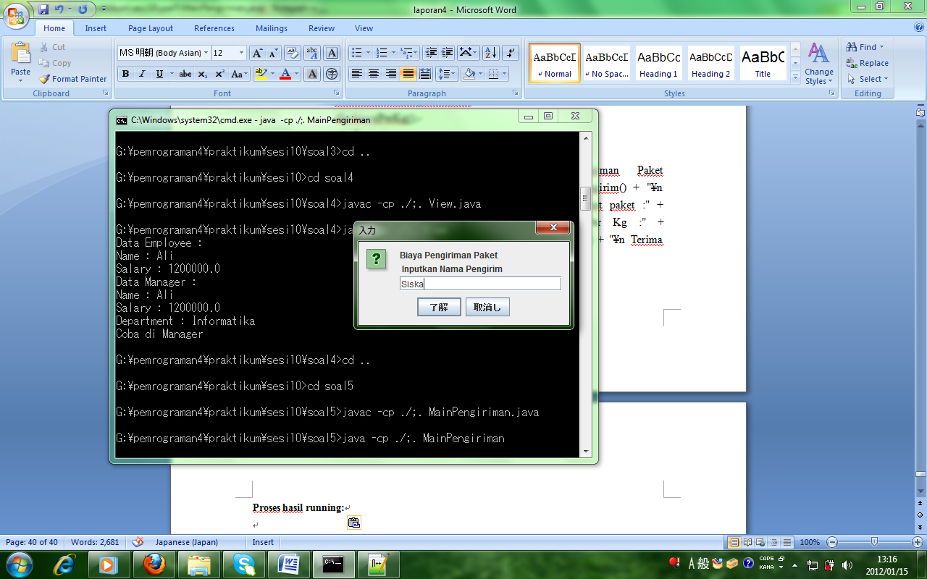

**Proses hasil input running:**

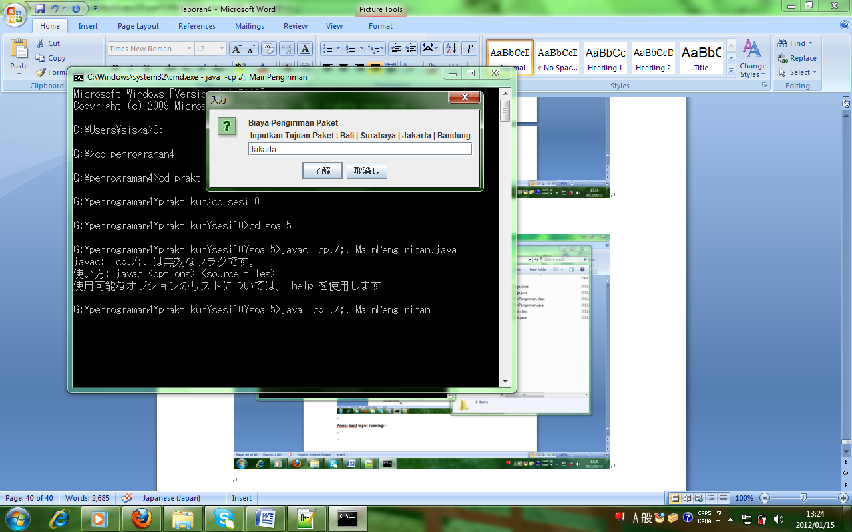

**Proses hasil input running:**

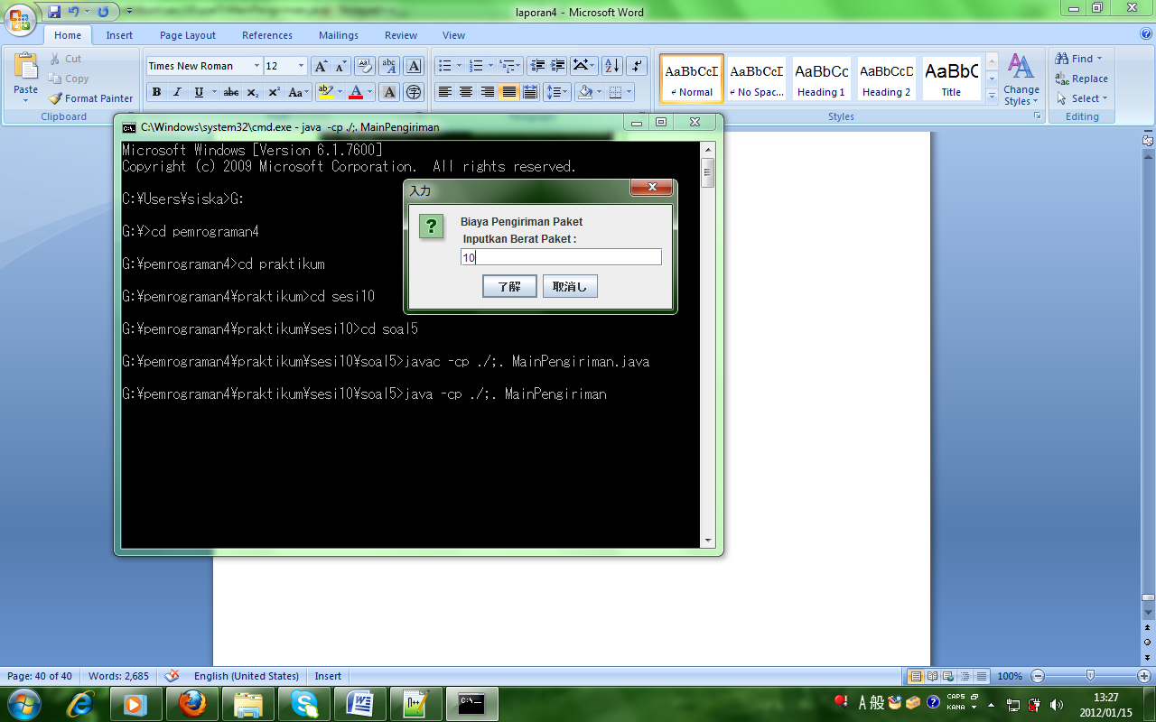

**Proses hasil input running:**

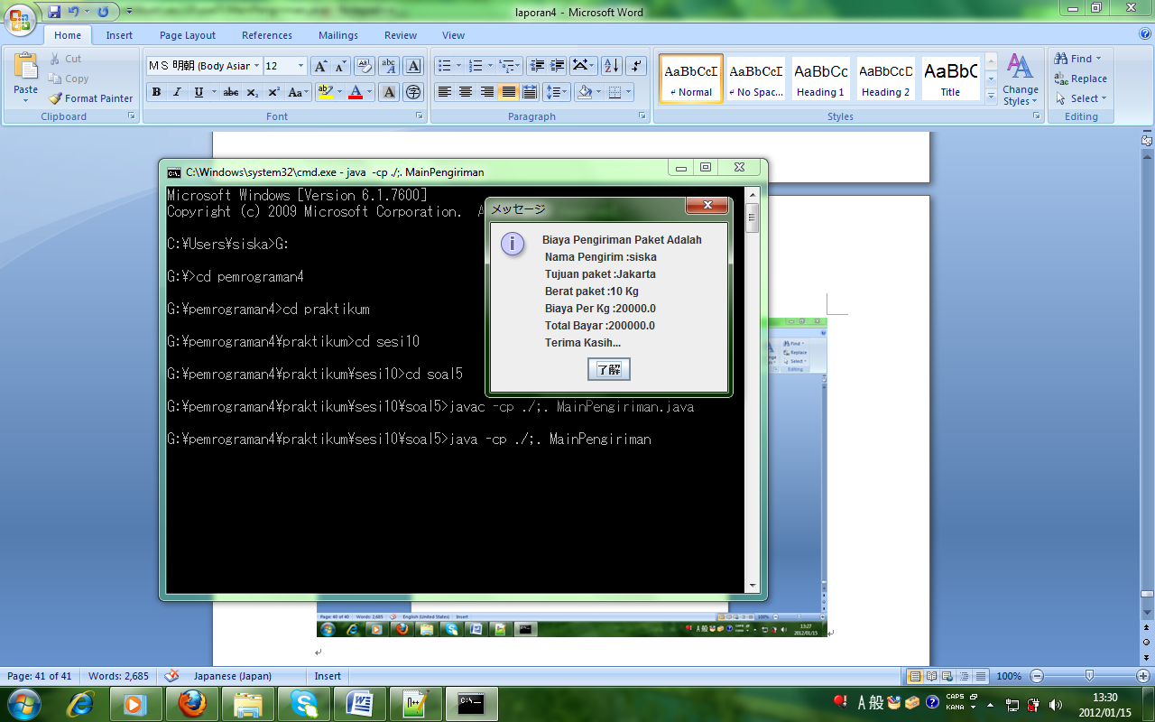

**Sesi-11 : - Abstract Class & Interface**

**Praktikum Soal 1**

**File Hewan.java dengan sintaks:**

abstract class Hewan{

protected String nama;

protected int jumKaki;

protected boolean bisaTerbang = false;

public Hewan(String nama, int kaki, boolean terbang){

this.nama = nama;

jumKaki = kaki;

bisaTerbang = terbang;

}

public abstract void bersuara();

public static void makan(){

System.out.println("nyam, nyam, nyam");

}

public void isHewan(){

System.out.println("nama : " + nama);

System.out.println("jumlah kaki : " + jumKaki);

System.out.println("bisa terbang : " + bisaTerbang);

}

}

**File Manusia.java dengan sintaks:**

interface Manusia{

public void menyanyi();

public void ketawa();

}

**File Perkutut.java dengan sintaks:**

class Perkutut extends Hewan{

public Perkutut(){

super("perkutut",2,true);

}

public void bersuara(){

System.out.println("\ncuit, cuit, cuit");

}

public static void main(String[] args){

Perkutut p = new Perkutut();

p.isHewan();

p.bersuara();

}

}

**File Sapi.java dengan sintaks:**

class Sapi extends Hewan{

public Sapi(){

super("sapi", 4, false);

}

public void bersuara(){

System.out.println("\nemoh...., emoh....");

}

public static void main(String[] args){

Sapi s = new Sapi();

s.isHewan();

s.bersuara();

}

}

**File SpongeBob.java dengan sintaks:**

class SpongeBob extends Hewan implements Manusia{

public SpongeBob(){

super("sponge bob", 2, false);

}

public void bersuara(){

System.out.println("\nhallo patrick...");

}

public void menyanyi(){

System.out.println("nye, nye, nye, wik, wik, wik");

}

public void ketawa(){

System.out.println("kek, kek, kek");

}

public static void makan(){

System.out.println("uenak tenan...");

}

public void makan2(){

super.makan();

}

public static void main(String[] args){

SpongeBob s = new SpongeBob();

s.isHewan();

s.bersuara();

s.menyanyi();

s.ketawa();

s.makan2();

Hewan.makan();

makan();

}

}

**Proses hasil running:**

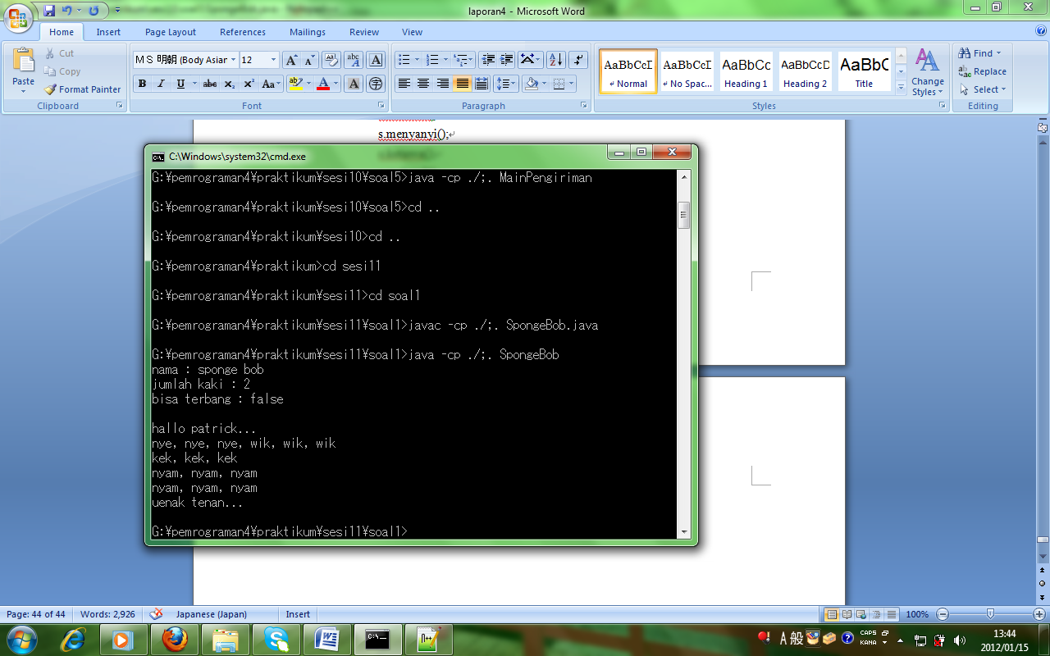

**Praktikum Soal 2**

**File A.java dengan sintaks:**

abstract class A{

abstract public void method2();

public void method1(){

System.out.println("method konkrit dari class A");

}

}

**File B.java dengan sintaks:**

class B extends A{

public void method2(){

System.out.println("method abstrak yang sudah menjadi konkrit dalam class B");

}

}

**File Latjava.java dengan sintaks:**

class Latjava{

public static void main(String[] args){

B ob = new B();

ob.method1();

ob.method2();

}

}

**Proses hasil running:**

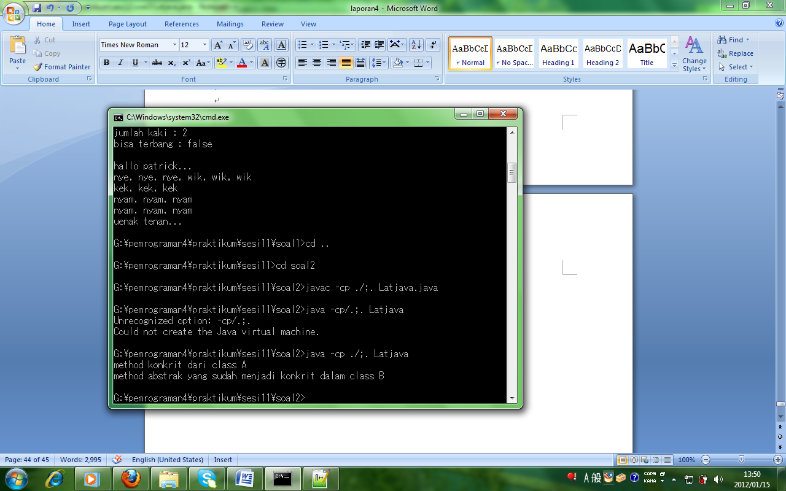

**Praktikum Soal 3**

**File GraphicObject.java dengan sintaks:**

abstract class GraphicObject{

int x, y;

void moveTo(int newValueX, int newValueY){

x = newValueX;

y = newValueY;

}

abstract void drawShape();

abstract void resize();

}

**File Cicle.java dengan sintaks:**

public class Circle extends GraphicObject{

void resize(){

System.out.println("Circle Resize");

}

void drawShape(){

System.out.println("Circle Shape");

}

void position(){

System.out.println(this.x + this.y);

}

}

**File Main.java dengan sintaks:**

public class Main{

public static void main(String[] args){

Circle Lingkaran = new Circle();

Lingkaran.moveTo(5,5);

Lingkaran.drawShape();

Lingkaran.resize();

Lingkaran.position();

}

}

**Proses hasil running:**

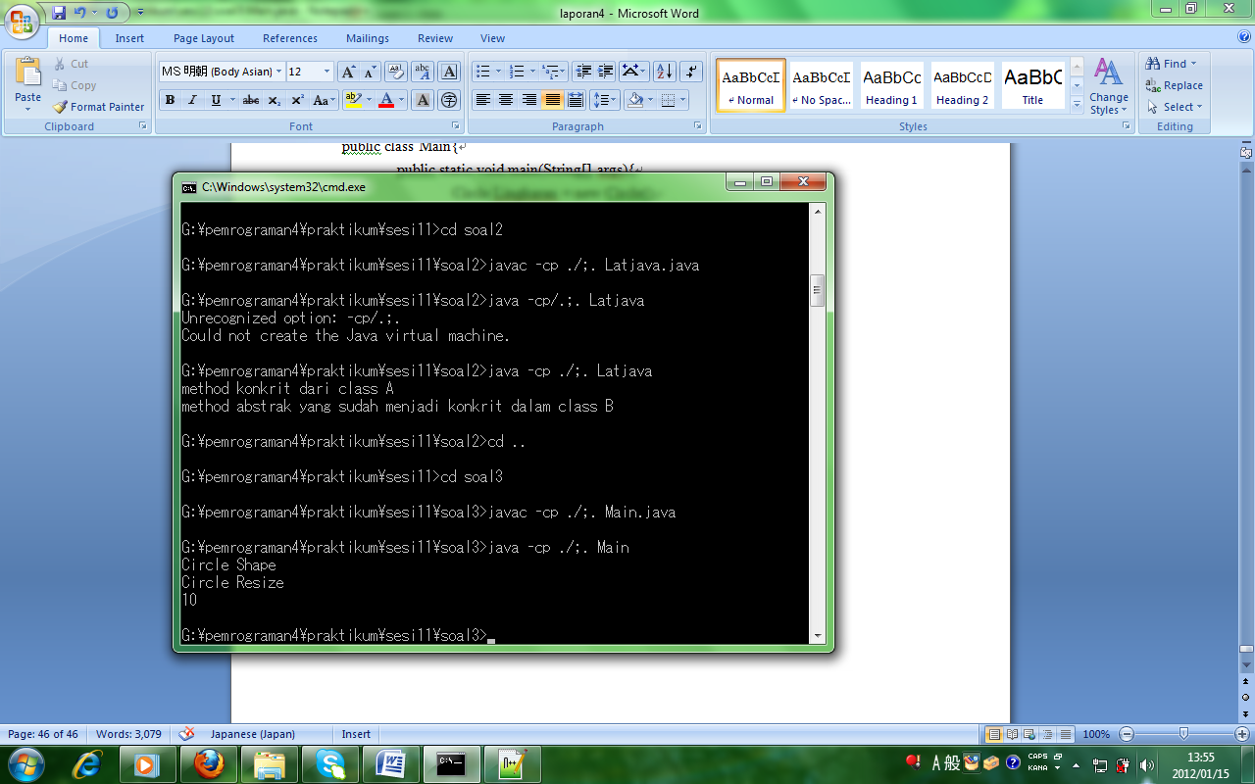

**Praktikum Soal 4**

**File Vehicle.java dengan sintak:**

abstract class Vehicle{

int numofGears;

String color;

abstract boolean hasDiskBrake();

abstract int getNoofGears();

}

**File Shape.java dengan sintaks:**

abstract class Shape{

public String color;

public Shape(){

}

public void setColor(String c){

color = c;

}

public String getColor(){

return color;

}

abstract public double area();

}

**File Point.java dengan sintaks:**

public class Point extends Shape{

static int x, y;

public Point(){

x = 0;

y = 0;

}

public double area(){

return 0;

}

public double perimeter(){

return 0;

}

public static void print(){

System.out.println("point: " + x + "," + y);

}

public static void main(String[] args){

Point p = new Point();

p.print();

}

}

**Proses hasil running:**

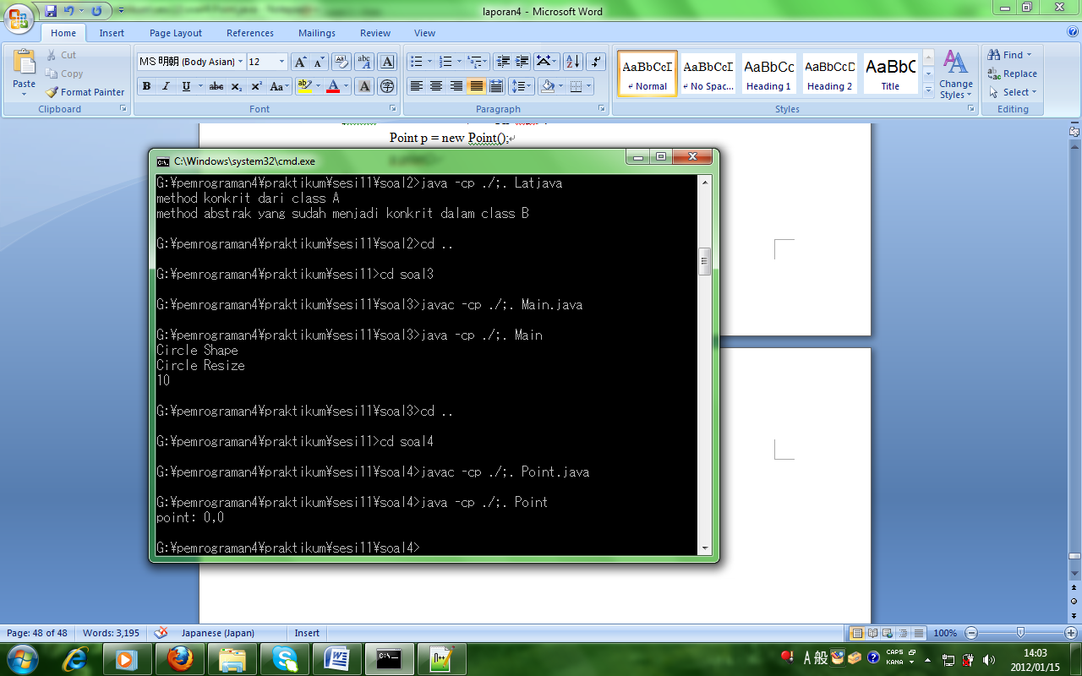

**Praktikum Soal 5**

**File Mobil.java dengan sintaks:**

public class TestMobil{

public static void main(String[] args){

Mobil mobil = new Mobil(){

public void injakPedalGas(){

System.out.println("Mobil Berjalan...");

}

};

Kijang kijang = new Kijang();

BMW bmw = new BMW();

mobil = kijang;

mobil.injakPedalGas();

mobil = bmw;

mobil.injakPedalGas();

}

}

**File Kijang.java dengan sintaks:**

public class Kijang extends Mobil{

public void injakPedalGas(){

System.out.println("Mobil melaju dengan kecepatan 80 km/jam...");

}

}

**File BMW.java dengan sintaks:**

public class BMW extends Mobil{

public void injakPedalGas(){

System.out.println("Mobil melaju dengan kecepatan 100 km/jam...");

}

}

**File TestMobil.java dengan sintaks:**

public class TestMobil{

public static void main(String[] args){

Mobil mobil = new Mobil(){

public void injakPedalGas(){

System.out.println("Mobil Berjalan...");

}

};

Kijang kijang = new Kijang();

BMW bmw = new BMW();

mobil = kijang;

mobil.injakPedalGas();

mobil = bmw;

mobil.injakPedalGas();

}

}

**Proses hasil running:**

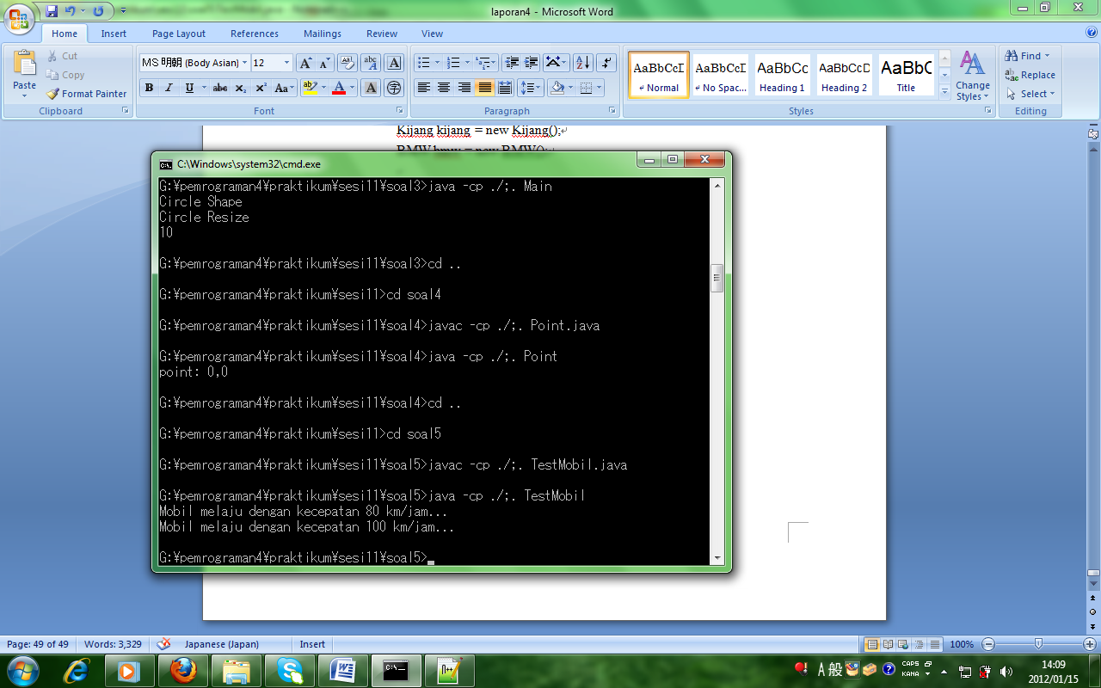

Sesi 12

**File DatabaseMahasiswa.java dengan sintaks:**

package aplikasi.mahasiswa;

public interface DatabaseMahasiswa {

public void simpan(Mahasiswa m);

}

**File AplikasiMahasiswa.java dengan sintaks:**

package aplikasi.mahasiswa;

import java.util.List;

import java.util.ArrayList;

public class AplikasiMahasiswa {

public static void main(String[] xx){

Mahasiswa m1 = new Mahasiswa();

m1.setNpm("123");

m1.setNama("Endy");

Mahasiswa m2 = new Mahasiswa();

m2.setNpm("456");

m2.setNama("Adi");

List<Mahasiswa> daftarMahasiswa = new ArrayList<Mahasiswa>();

daftarMahasiswa.add(m1);

daftarMahasiswa.add(m2);

List<DatabaseMahasiswa> db = new ArrayList<DatabaseMahasiswa>();

// database csv

DatabaseMahasiswaCsv dbCsv = new DatabaseMahasiswaCsv("mhs.txt", false);

db.add(dbCsv);

// Database Access

//DatabaseMahasiswaAccess dbAccess = new DatabaseMahasiswaAccess("dbmahasiswa");

//db.add(dbAccess);

DatabaseMahasiswaMySQL dbMySQL

= new DatabaseMahasiswaMySQL(

"localhost", "3306", "belajar", "root", "admin");

db.add(dbMySQL);

for(DatabaseMahasiswa d : db){

for(Mahasiswa m : daftarMahasiswa){

d.simpan(m);

}

}

}

}

**File DatabaseMahasiswaAccess.java dengan sintaks:**

package aplikasi.mahasiswa;

import java.sql.Connection;

import java.sql.DriverManager;

import java.sql.PreparedStatement;

public class DatabaseMahasiswaAccess implements DatabaseMahasiswa {

private Connection connection;

private String url;

private String sql = "insert into mahasiswa (npm, nama) values (?, ?)";

public DatabaseMahasiswaAccess(String dsn){

try {

Class.forName("sun.jdbc.odbc.JdbcOdbcDriver");

url = "jdbc:odbc:"+dsn;

} catch (Exception err){

err.printStackTrace();

}

}

public void simpan(Mahasiswa m){

try {

// harusnya connection diinstankan sekali saja

// dan direuse berkali2

// tapi untuk ODBC harus open close tiap statement

connection = DriverManager.getConnection(url);

PreparedStatement ps = connection.prepareStatement(sql);

ps.setString(1, m.getNpm());

ps.setString(2, m.getNama());

ps.executeUpdate();

connection.close();

} catch (Exception err){

err.printStackTrace();

}

}

}

**File DatabaseMahasiswaCsv.java dengan sintaks:**

package aplikasi.mahasiswa;

import java.io.File;

import java.io.FileWriter;

public class DatabaseMahasiswaCsv implements DatabaseMahasiswa {

private Boolean pakaiHeader;

private File file;

private FileWriter writer;

public DatabaseMahasiswaCsv(String lokasi, Boolean header){

try {

pakaiHeader = header;

file = new File(lokasi);

writer = new FileWriter(file, true);

// untuk file kosong, tulis header bila perlu

if(pakaiHeader && !(file.length() > 0)){

writer.write("npm,nama\n");

writer.flush();

}

} catch (Exception err){

err.printStackTrace();

}

}

public void simpan(Mahasiswa m){

try {

String npm = m.getNpm() == null ? "" : m.getNpm();

String nama = m.getNama() == null ? "" : m.getNama();

String record = String.format("%s,%s%n", npm, nama);

writer.write(record);

writer.flush();

} catch (Exception err){

err.printStackTrace();

}

}

}

**File DatabaseMahasiswaMySql.java dengan sintaks:**

package aplikasi.mahasiswa;

import java.sql.Connection;

import java.sql.DriverManager;

import java.sql.PreparedStatement;

public class DatabaseMahasiswaMySQL implements DatabaseMahasiswa {

private Connection connection;

private String sql = "insert into mahasiswa (npm, nama) values (?, ?)";

private PreparedStatement ps;

public DatabaseMahasiswaMySQL(String dbHost, String dbPort, String dbName, String dbUser, String dbPass){

try {

Class.forName("com.mysql.jdbc.Driver");

String url = "jdbc:mysql://"+dbHost+":"+dbPort+"/"+dbName;

connection = DriverManager.getConnection(url, dbUser, dbPass);

ps = connection.prepareStatement(sql);

} catch (Exception err){

err.printStackTrace();

}

}

public void simpan(Mahasiswa m){

try {

ps.setString(1, m.getNpm());

ps.setString(2, m.getNama());

ps.executeUpdate();

} catch (Exception err){

err.printStackTrace();

}

}

}

**File Mahasiswa.java**

package aplikasi.mahasiswa;

public class Mahasiswa {

private String npm;

private String nama;

public String getNpm(){

return npm;

}

public void setNpm(String n){

npm = n;

}

public String getNama(){

return nama;

}

public void setNama(String n){

nama = n;

}

}

**Proses hasil running:**

